**DAILY ONLINE ACTIVITIES SUMMARY**

|  |  |  |  |  |  |  |  |  |
| --- | --- | --- | --- | --- | --- | --- | --- | --- |
| **Date:** | **22-05-2020** | | | | | **Name:** | **Shah Dhruvil Amit** | |
| **Sem & Sec** | **6th - B** | | | | | **USN:** | **4AL17CS083** | |
| **Online Test Summary** | | | | | | | | |
| **Subject** | | **OPERATION RESEARCH** | | | | | | |
| **Max. Marks** | | **30** | | **Score** | | | **30** | |
| **Certification Course Summary** | | | | | | | | |
| **Course** | **Build an e-commerce with ReactJS** | | | | | | | |
| **Certificate Provider** | | | **learncodeonline** | | **Duration** | | | **As per progress(no duration specified)** |
| **Coding Challenges** | | | | | | | | |
| **Problem Statement: 2 java and 1 C program** | | | | | | | | |
| **Status: executed** | | | | | | | | |
| **Uploaded the report in GitHub** | | | | | **Yes** | | | |
| **If yes Repository name** | | | | | <https://github.com/DhruvilShah99/Daily-Updates> | | | |
| **Uploaded the report in slack** | | | | | **Yes** | | | |

Online Test Details: (Attach the snapshot and briefly write the report for the same)

First I A of OPERATION RESEARCH

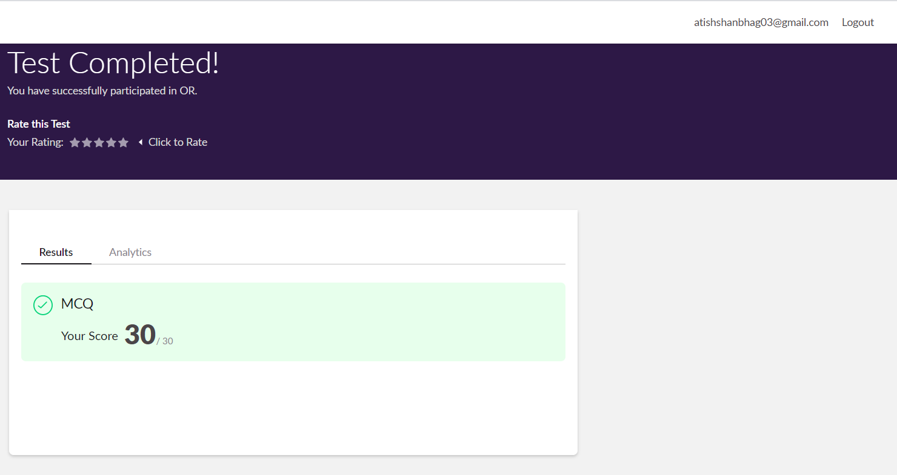

Certification Course Details: (Attach the snapshot and briefly write the report for the same)

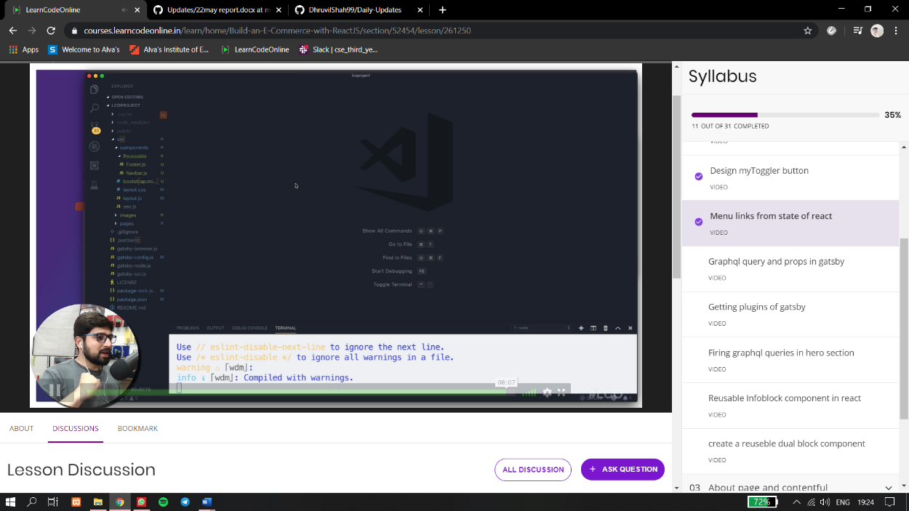

In todays session from 10:40 to 1:00 for online certification I have studied to design myToggler button as well as installed gatsby project and worked on it. I also had an introduction to the states in react and how to handle them.

Coding Challenges Details: (Attach the snapshot and briefly write the report for the same)

Problem statements are available in the GitHub account<https://github.com/DhruvilShah99/Daily-Updates>

OUTPUT SCREEN-SHOTS

Program 1(C)

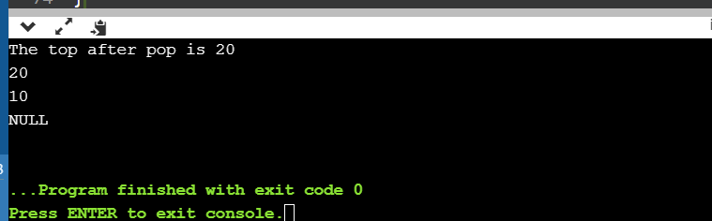

Program 2(Java)

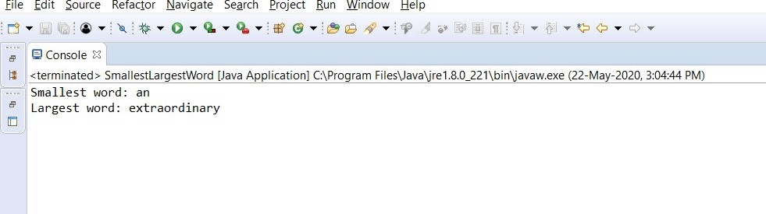

Program 3(Java)

